*Hometown kid makes it big in Italian American Studies*

Homecoming Event…

**Fred Gardaphe’**

Distinguished Professor of English & Italian American Studies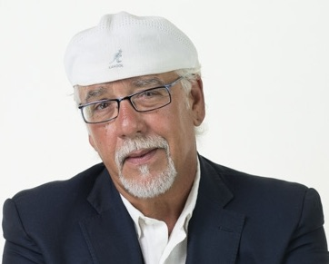 Queens College, CUNY

Professor Gardaphe will read from his memoir-in-progress, *A Generation Removed*, a series of interconnected stories of his grandfather's travels to the U.S, in the early twentieth century, and Fred’s travels to Italy in the late 1970s. Fred grew up in Melrose Park and graduated from Fenwick. His grandfather helped build the Sacred Heart Seminary (the Italian Cultural Center) and Fred has always been a supporter of the library and

A leading expert in Italian American Studies, Gardaphe is one of the highest ranking academics in the World. He directs the Program at Queens College, City University of New York and works at the John D. Calandra Italian American Institute.  Previously he helped to create the Italian American Studies program at Stony Brook University which he directed from 1998-2008.  From 1978-1998 in his position professor ofEnglish and Educational Studies at Columbia College Chicago. he created and taught writing, literature courses and courses in Italian American film and literature from 1978-1998.

Gardaphe is Associate Editor of *Fra Noi*, an Italian American monthly newspaper, editor of the Series in Italian American Studies at State University of New York Press, and co-founding-co-editor of *Voices in Italian Americana, a literary journal and cultural review*.

Saturday August 3, 10am

Florentine Room, Italian Cultural Center, Reservations required—access Casa Italia website and click on______________________ or register directly a

