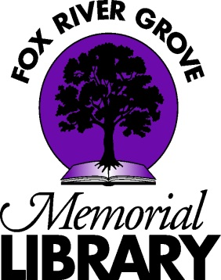

Fox River Grove Memorial Library
Job Description

ADULT SERVICES LIBRARIAN

The Adult Services Librarian leads the smooth operation of the adult collection, adult programming, and readers’ advisory services. This is a part-time, 30-hour-per-week, non-exempt position. The Adult Services Librarian reports to the Library Director.

ESSENTIAL JOB FUNCTIONS
- Fulfills all opening and closing procedures
- Works circulation desk and all related duties, including troubleshooting minor computer and printer problems for patrons, shelving materials in the absence of pages, and ordering interlibrary loans
- Answers directional and general reference questions
- Provides readers’ advisory using a variety of digital and physical methods
- Assists patrons in the use of library-provided mobile apps
- Trains new employees
- Coordinates circulation desk and page schedules in collaboration with Assistant to the Director and Youth Services Manager
- Attends and participates in all staff meetings
- Attends educational workshops when possible
- Plans adult programming within budget restrictions
- Liaises with the Friends of the Library under supervision of the Director
- Checks general library email and delegates as needed
- Backs up Technical Services Librarian in cataloging and management of Koha ILS
- Meets monthly with the Director and Youth Services Manager
- Other duties as assigned

COLLECTION DEVELOPMENT
- Reviews professional catalogs and assigns selection and purchase of materials for the adult department
- Tracks adult materials collection budget under supervision of the Director
- Selects and evaluates adult materials for replacement or withdrawal from the library collection
- Receives shipments of materials and verifies accuracy of shipments
- Other duties as assigned

ESSENTIAL QUALIFICATIONS
- Education: Bachelor’s Degree from an accredited college or university
- Experience: 1-3 years’ library experience
- Skills: Microsoft Office, email, social media, and familiarity with web-based searching and applications are required. Knowledge of literature old and new. Understanding of library’s role in the community. Comfort with working with the public. Able to pass background check. Demonstrates an understanding of the importance of teamwork in a small library. Able to multitask. Comfort with 21st-century office technology.

PHYSICAL DEMANDS
The physical demands described here are representative of those that must be met by an employee to successfully perform the essential functions of this job. Reasonable accommodations may be made to enable individuals with disabilities to perform the essential functions.

While performing the duties of this job, the employee is regularly required to stand; walk; use hands to finger, handle, or feel; and reach with hands and arms. The employee is regularly required to talk and hear. The employee must regularly retrieve from and replace books on high and low shelves. The employee must occasionally lift up to 25 pounds and/or push carts up to 50 pounds. Specific vision abilities required by this job include close vision, distance vision, depth perception, and ability to adjust focus. Typing on a computer keyboard and interacting with computer screens are required.

