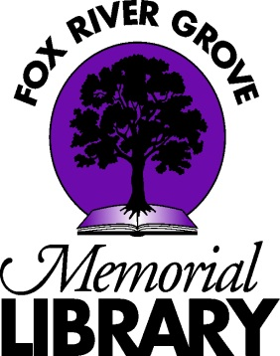

Fox River Grove Memorial Library
Job Description

TECHNICAL SERVICES COORDINATOR

The Technical Services Coordinator leads the smooth operation of technical and circulation services and assists in adult services. This is a 36-hour-per-week, part-time, non-exempt position. The Technical Services Coordinator reports to the Library Director.

ESSENTIAL JOB FUNCTIONS
- Fulfills all opening and closing procedures
- Works circulation desk and all related duties, including troubleshooting minor computer and printer problems for patrons and shelving materials in the absence of pages
- Answers directional, general reference, and readers’ advisory questions
- Assists patrons in the use of library-provided mobile apps
- Oversees and executes interlibrary loans
- Backs up Assistant to the Director in weekly balancing of fines, fax, copier, and book sale money for banking and preparing deposit paperwork
- Repairs books as needed
- Deletes all weeded material from catalog and OCLC
- Updates and configures changes for Koha ILS
- Issues overdue notices and deals with long-term overdue/lost items
- Catalogs Local History Collection
- Checks general library email and delegates as needed
- Attends and participates in all staff meetings
- Attends educational workshops when possible
- Other duties as assigned

COLLECTION DEVELOPMENT
- Reviews professional catalogs and selects materials for the adult department as assigned
- Oversees all aspects of technical services (cataloging, labeling, etc.)
- Arranges displays of community information
- Receives shipments of materials and verifies accuracy of shipments
- Other duties as assigned

ESSENTIAL QUALIFICATIONS
- Education: Bachelor’s Degree from an accredited college or university
- Experience: 1-3 years’ library experience
- Skills: Microsoft Office, email, and familiarity with web-based searching and applications are required. Aptitude for online database management. Comfort with uncertainty. Understanding of library’s role in the community. Able to work with the public. Able to pass background checks including credit check. Demonstrates an understanding of the importance of teamwork in a small library. Able to multitask.

PHYSICAL DEMANDS
The physical demands described here are representative of those that must be met by an employee to successfully perform the essential functions of this job. Reasonable accommodations may be made to enable individuals with disabilities to perform the essential functions.

While performing the duties of this job, the employee is regularly required to stand; walk; use hands to finger, handle, or feel; and reach with hands and arms. The employee is regularly required to talk and hear. The employee must regularly retrieve from and replace books on high and low shelves. The employee must occasionally lift up to 25 pounds and/or push carts up to 50 pounds. Specific vision abilities required by this job include close vision, distance vision, depth perception, and ability to adjust focus. Typing on a computer keyboard and interacting with computer screens are required.

