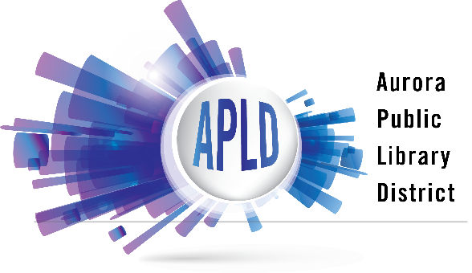

SOCIAL MEDIA POLICY

The Aurora Public Library District maintains various social media applications and services to facilitate an online platform of communication between library staff and library users about library programs, resources, and services. The library’s social media presence is maintained and monitored by Aurora Public Library District staff under the direction of the Communications Manager.
While the library respects differing opinions, comments, posts, and messages will be monitored and reviewed for content, relevance, and appropriateness. The Aurora Public Library District reserves the right to remove content that violates this Social Media Policy and to block users who repeatedly violate the policy. Prohibited content includes:
- Obscene, sexist, hateful or racist content
- Personal attacks, insults or threatening language
- Content that violates local, state, or federal law or which encourages illegal activity
- Potentially libelous statements
- Plagiarized material
- Private or personal information submitted without consent
- Comments or links unrelated to the content of the discussion
- Commercial promotions or spam
- Content that advocates a candidate, referendum, or campaign
- Any messages deemed to be in violation of copyright, trademark right or other intellectual property right of any third party
Photos submitted to Aurora Public Library District social media may be used by the library for publicity, advertising, or web content. Content posted on library social media sites is subject to the Illinois Freedom of Information Act and state record retention laws. The Aurora Public Library District is not responsible or liable for content posted by any person in any forum.

Approved by the Aurora Public Library District Board of Library Trustees on September 22, 2021

