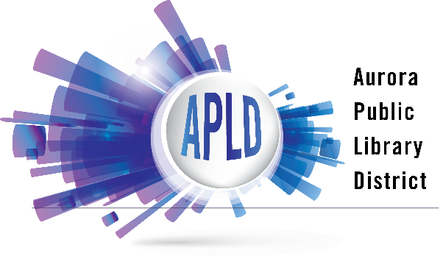

Internet and Computer Use Policy
The Aurora Public Library offers public access to computer and the Internet, as well as wireless access to the Internet on personal devices. The library filters Internet access in accordance with federal law regarding acceptance of E-Rate funding. Serving a community of 197,757, the Aurora Public Library recognizes that providing computer and Internet access is an essential component of library service. The library serves a diverse community including six school districts across four counties. Over 12% of households lack access to robust computing and Internet services for critical functions such as completing online job applications, banking, supporting their child’s education, and general information access.*

The Aurora Public Library reserves the right to monitor and exercise any appropriate measures over customers’ use of the Internet to reasonably ensure compliance with library policies. The library reserves the right to classify any action, access, or operation on the Internet as inappropriate.

The library reserves the right to suspend or revoke computer and Internet use privileges if a customer fails to comply with the following use guidelines:
- Public access computers and wireless Internet access may not be used to access pornographic materials.
- Public access computers and wireless Internet access may not be used for any purposes that violate U.S. or State laws, including copyright laws.
- Other illegal or unacceptable uses include, but are not limited to: bullying; harassment; libel or slander; solicitation; accessing websites that are harmful to minors or depict child pornography; and unauthorized monitoring of electronic communications.
- Computer and wireless users must comply with the library’s Customer Behavior & Security Policy, Unattended Child Policy, and all other applicable library policies.

The library reserves the right to exercise any appropriate measures necessary to protect our computer systems and cannot guarantee the integrity of data on personal storage devices.
- Computer and wireless users may not interfere with or disrupt network users, services or equipment.
- Propagation of computer viruses and worms, hacking, and using the network to make unauthorized entry to any other machine accessible via the network are all prohibited.
- Any personal software requiring either administrator access to install, or a reboot of the computer, may not be used on any library computer.
- The library is not responsible for any problems that may occur when using library computers, including loss of files or data.
- The library makes reasonable efforts to protect personal privacy, including the use of software that deletes user activity. Computer users are responsible for protecting their data.

The library does not collect, use, or process personal data. The library does maintain computer usage logs for a limited period of time. Computer use is protected by the Library Records Confidentiality Act (75 ILCS 70/1-2).

Children of any age may use library computers and wireless to access the Internet. A parent or a designated caregiver is responsible for the child’s Internet use. Parents and caregivers of children under age 12 have the ability to restrict a child’s Internet access privileges.

* https://www.census.gov/quickfacts/auroracityillinois

