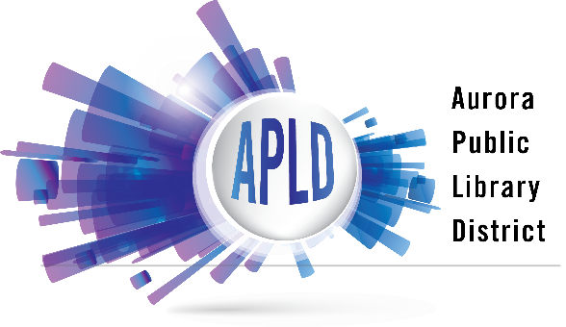

Information Services Policy

Information Service Philosophy
The Aurora Public Library District is dedicated to supporting lifelong learning and access to information, knowledge and ideas. The library strives to provide quality informational resources and services for users of all ages.

Standards and Ethics

The library adopts and adheres to the American Library Association’s Code of Ethics.

Staff serve all users on an equal basis without regard to race, national origin, age, gender, sexual orientation, background, appearance, physical or mental abilities, income or living situation, personal view of the customer, the subject matter being researched, or the purpose of the inquiry. We will respect the confidentiality of the question and of the identity of the customer. If necessary to serve the customer, staff may consult with each other or with staff at other libraries, agencies, and organizations.

Our goal is to provide accurate information and materials in an efficient, courteous, and timely manner. Staff will assist library customers with any information needs using the library’s available resources according to the policies, practices, and guidelines established by the Aurora Public Library District Board of Library Trustees. Library staff strive to provide complete and accurate answers while guiding and instructing customers in the use of library resources.

Information service is provided at all locations and for all ages, in person, by telephone, electronically and by mail. Non-residents will receive the same service as residents and will be assisted with local library resources, with the exception of holds and inter-library loans. If the request proves to be beyond the scope of the resources available at the library, non-resident customers may be referred to their home libraries or other agencies for service.

Scope of Service

Staff will assist with readers advisory, facilitate or support book discussion groups, and promote library materials. Genealogical services will be provided by service desk staff first and may be referred to the Genealogy and Local History Librarian for extensive searches. Sign language interpreters or other accommodations will be made available with seven (7) days’ notice.

Certain types of assistance are beyond the scope of the library’s service capacity:
- Legal, medical, financial, or tax advice
- Completing forms (including online forms) for customers
- Extensive troubleshooting or alteration/repair of personal electronic devices
- Translation assistance will be provided where staff expertise is available. For translations beyond our abilities, staff will refer customers to other appropriate resources to find translators.
Fees

The Aurora Public Library District does not charge for reference service. Fees may be charged for photocopies or printouts. The cost of postage may also be charged for mailing the results of genealogical/local history searches.

One-On-One Assistance

Library staff may be available to work one-on-one with customers to assist in their information needs. Staff instructional sessions include, but are not limited to, using library’s research databases, genealogical searching and training on specific electronic devices.

Proctoring

The library offers proctoring services by appointment at all three locations, depending on staffing and availability. In the event of a cancellation by the customer, it is the responsibility of the customer to reschedule the exam. Appointments must be scheduled at least 7 days prior to the date of the examination.

Approved by the Aurora Public Library District Board of Library Trustees
August 25, 2021

