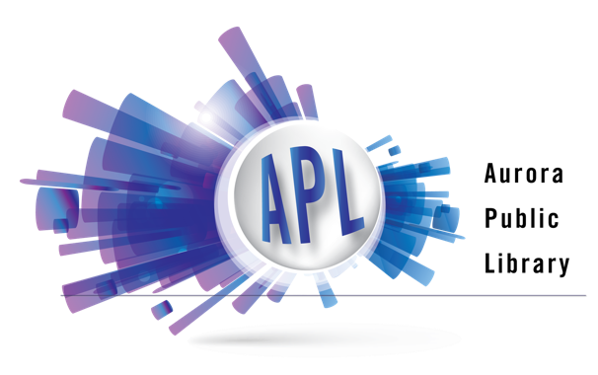

Customer Behavior and Security Policy

The Aurora Public Library District encourages the public to use its facilities, materials, and services to discover, create, connect, and succeed.

These guidelines ensure the safe, comfortable, and respectful use of the library for all.

Customers can, in return, expect the following from the library and library staff:
  - To receive helpful, prompt, and knowledgeable service
  - To foster a welcoming, safe, and inclusive environment for all people

Expectations of Customer Behavior:

- Customers are expected to treat others, spaces, materials, and services with respect.

- Behavior which may cause safety concerns or interfere with others’ use of library facilities is prohibited, including, but not limited to: loud, abusive, obscene or threatening language or audio, physical or verbal harassment of staff or other customers; or offensive, pervasive odor that interferes with others’ use of the library.

- Customers may consume snacks and covered, non-alcoholic drinks in the library. In some designated areas, including computer areas, no food or drink is allowed. Hot food, odorous foods, and large meals are also not allowed in the library.

- Drinking alcoholic beverages on library property is prohibited. Using illegal drugs on library property is prohibited. Entering the library in a perceived or actual state of intoxication or in a perceived or actual state of being under the influence is prohibited. Smoking or vaping is not permitted in the library or on library grounds.

- For the safety of all, customers must keep high traffic areas, doorways, aisles, and stairways clear.

Taking photos, making videos, or recording audio of library customers without their consent, or in the case of minor customers, the consent of their caregivers, is prohibited. Requests to use library facilities as a setting for photography, filming or recording should be directed to Administration, and will be evaluated in terms of impact on library operations and public use of the library.
- Service animals that are individually trained to do work or perform tasks for people with disabilities are allowed in the library. Animals not fitting the legal description of a service animal are prohibited.

- Any conduct in violation of library policies, or federal, state, or local law, is prohibited. The library reserves the right to involve law enforcement if federal, state, or local laws are violated.

- Failure to abide by these expectations may result in loss of library privileges, up to and including being asked to leave the library and temporary banning. Any customer whose privileges have been denied may have the decision reviewed by the Board of Library Trustees upon written request.

Security Camera Placement and Purpose Guidelines:
Security cameras are used to enhance the safety and security of library users and staff, by discouraging violations of this policy, to assist library staff in preventing the occurrence of any violations, and when necessary, to provide law enforcement assistance in prosecuting criminal activity.

- Signs will be posted at all entrances informing the public and staff that security cameras are in use. Cameras will not be continuously monitored, so the public should take appropriate precautions for their safety and for the security of their personal property.

- Video records and still photographs may be used by authorized individuals to identify those responsible for library policy violations, criminal activity on library property or actions considered disruptive to normal library operations as described in this policy. Authorized individuals include library administration, security, staff designated and trained as PIC (Person in Charge). Police are only considered authorized and granted access to security cameras and footage upon obtaining an official warrant. The Executive Director may release security camera footage to the Aurora Police Department without a warrant in connection with documented incidents reported to the police by the staff of the Aurora Public Library District.

Approved by the Aurora Public Library Board of Library Trustees August 25, 2021
Effective September 8, 2021

