Crisis Management Plan
Lockport Branch Edition

Approved and implemented by the
Board of Trustees on August 26, 2014

Purpose of the Plan
The purpose of the White Oak Library District Crisis Management Plan is to provide direction for library staff in dealing with a host of issues they may face, including natural or man-made disasters, illegal or violent patron behavior, etc. This plan will minimize the negative impacts of said crises and help hasten a return to the normal operations of the organization.

Succession of Authority

The Director will direct the crisis management plan. In the absence of the Director, the Assistant Director, the Branch Manager of the affected Branch, and other key management staff will take part in directing this plan.
TELEPHONE NUMBERS:

Director: Scott Pointon - (h) 815-741-6824 (c) 815-351-9333

Assistant Director / Romeoville Branch Manager: Beverly Krakovec - (c) 815-666-5220

Crest Hill Branch Manager: Amy Byrne - (c) 815-262-6102

Lockport Branch Manager: Patricia Jarog – (c) 630-248-7829

Business Manager: Debra Chapp – (h) 815-836-8768 (c) 815-685-5632

Facilities Manager: John Jozwiak - (c) 630-210-4143

I.T. Manager: Michael Pezan - (c) 708-560-6081

Outreach Manager: Tina Williams – (c) 815-483-9076

Technical Services Manager: Brandon Swarthout – (c) 815-953-4740

Definition of “Librarian in Charge”
Many areas of this plan refer to the “Librarian in Charge”. Whenever the Director or relevant Branch Managers are present, they will serve as the Librarian in Charge. Recognizing the fact that our buildings are generally open seven days a week and that the Director and/or Branch Managers will not always be around, we have designated the person working at the adult reference desk to be the “Librarian in Charge” in their absence. This means that when it comes to decision making in a crisis situation, if no one of higher authority is reasonably available, decisions will have to be made and actions carried out by whoever is serving as the Librarian in Charge during that shift. If the person staffing the adult reference desk at the time of a crisis is a substitute librarian, then the highest seniority librarians and/or library staff members in the building will collaborate to carry out the role of Librarian in Charge.

Blood & Air Borne Pathogens

Blood-Borne Pathogens

It is quite possible for library materials to be returned with body fluids on their surface, including blood. In such cases, blood borne pathogens are a concern.

What to do first if a staff member contacts blood:

- Wash hands or any area of skin that may have touched the blood with soap and water. Do this immediately, and use gloves to finish handling the material.
- Take item to the Circulation Desk and have staff check the identity of the patron who last checked out the material.
- Circulation staff will note damage to item and alert Technical Services to withdraw it.
- Circulation staff will place the infected material in a hazardous waste bag and seal it. Give the safely bagged item to the Circulation Supervisor for disposal.
- An incident/accident report should be filled out, include name of patron that contaminated the material and any staff members involved in handling the item(s).
- In cases where the staff member wishes to be tested for infection; any positive results of that testing should be made available by the Director to the patron who contaminated the materials (so they may choose to receive medical attention).

Air-Borne Pathogens: Biological and Chemical

Biological agents are organisms or toxins that can kill or incapacitate people, livestock, and crops. The three basic groups of biological agents that would likely be used as weapons in a terrorist attack are bacteria, viruses, and toxins. Chemical agents are poisonous vapors, aerosols, liquids, and solids that have toxic effects on people, animals, or plants. Chemical agents are most likely to be released into the air during a terrorist attack or an industrial accident. Signs of a chemical agent release include multiple people having difficulty breathing; experiencing eye irritation; losing coordination; becoming nauseated; or having a burning sensation in the nose, throat, and lungs. Also, the presence of many dead insects or birds may indicate a chemical agent release.

If the air-borne agent is inside the library:

- Staff suspecting presence of an air-borne agent should take immediate action to move themselves and patrons away from the contaminated area.
- Staff should then immediately notify their supervisor of the problem. If the supervisor is not present, then the librarian in charge should be contacted.
- The librarian in charge will quickly try to define the impacted area and/or determine where the chemical is coming from, if possible.
- The librarian in charge will contact the Director / Assistant Director / Branch Manager / Facilities Manager to shut down the building’s air handling & circulation system. The librarian in charge, where practical, will consult with the Director or Branch Manager to determine if evacuation is necessary. They will also determine whether or not to call 911 and involve outside authorities.
Blood & Air Borne Pathogens (continued)

- When evacuation is necessary, staff and patrons should get out of the building(s) without passing through the contaminated area, if possible.
- Once outside, staff should move themselves and patrons away from the building, and congregate at the north edge of the parking lot (the part furthest from the library).

If the air-borne agent is outside the library:

- If the library receives information indicating the presence of an air-borne pathogen outside the library building, the librarian in charge should be notified immediately.
- The librarian in charge will use the library’s PA system to make an announcement informing all building occupants of the situation and inform them of the fact that the exterior doors will be closed and locked.
- All air handler units and fans will be shut down in mechanical room via power switches.
- Everyone remaining in the building should seek shelter in an internal room lacking an exterior window such as the staff entry hall, the PLC System Administrator’s office, the Adult staff workroom, or the Children’s staff workroom, and take disaster supplies such as flashlights, radios, etc. with them.
- Seal the room with duct tape and plastic sheeting if possible.
- Monitor local emergency radio broadcasts for instructions from authorities.

Bomb Threat

Staff member receiving call should use the form below to get all information possible from the person making the threat. Remember to be calm, be courteous, do not interrupt the caller, and above all listen to what they have to say. Other things to remember while on the call: Immediately activate the panic alarm button (located underneath each service desk), and discreetly let another staff member know you are dealing with a bomb threat call so they can alert others, especially the librarian in charge.
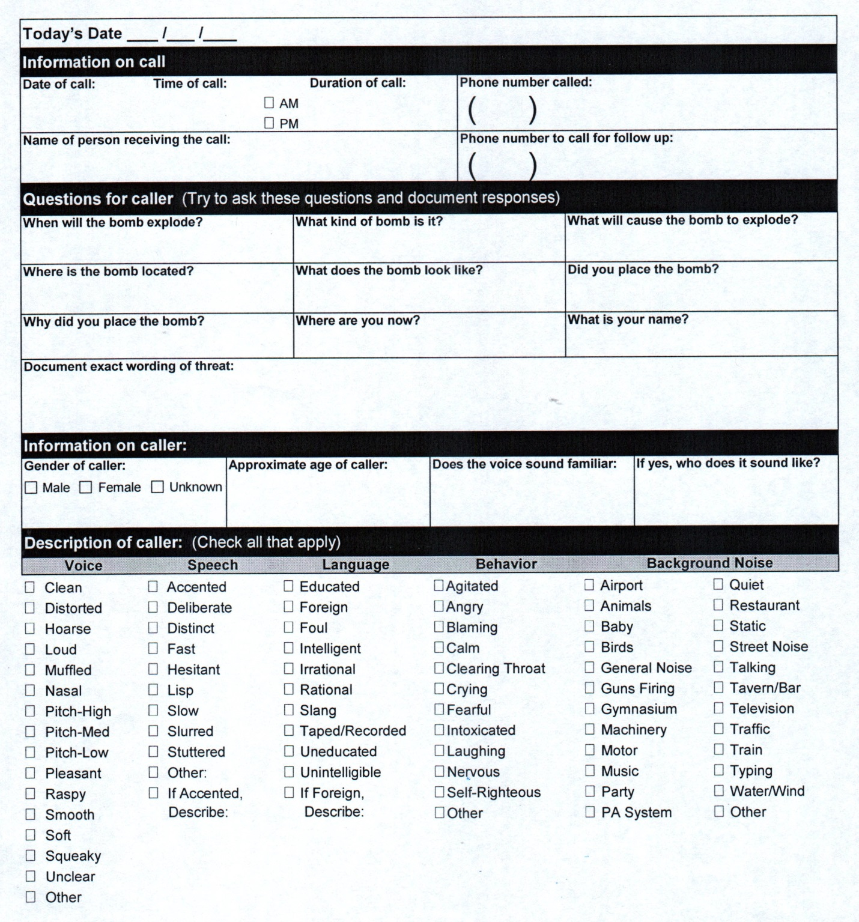

What to do next:

- If a bomb threat occurs during library open hours, the librarian in charge should be notified immediately to take charge. Speed is of the essence.
- The librarian in charge or their designee should immediately make the following announcement using the library’s PA system:
“Attention library patrons and staff. Please evacuate the library
immediately. Proceed to the nearest fire exit in a calm and orderly fashion
and exit the building.”
- Once all patrons and staff are safely out of the building, the librarian in charge should lock the facility to prevent public re-entry, contact the police by calling 911, and report everything they know about the bomb threat.
- After evacuating the building, staff and patrons should move away from the building and congregate in the north end of the parking lot (furthest from the library). A head count should be taken to verify all staff are out of the building.
- Once the building is completely evacuated and the police have been called, the person in charge will contact the Director. If the Director is unreachable, continue down the Succession list attempting to notify someone in a position of authority.
- Staff will be allowed to re-enter the building(s) only after the Lockport Police or other designated emergency personnel have made a thorough search of the premises and given an all clear to the Director or the librarian in charge of the building.

Dangerous or Armed Person Attack

GENERAL GUIDELINES:
This section is intended to guide staff in dealing with a dangerous or armed person. “Dangerous or Armed” in this situation is defined as someone who:
- Is seen committing violence or a violent act inside the library;
- Has a weapon in-hand (gun, knife, bomb, etc);
- Says they have a (concealed) weapon and threatens to use it;
- Is using verbal threats of violence toward a patron or staff member;
- Seems mentally unstable and likely to cause injury to themselves or others
Actions taken by staff should be dictated by whether the dangerous person in question has committed a violent crime, or if they are thus far simply threatening to commit a crime of violence. If a violent crime has already been committed, any staff member who has witnessed the act, and can safely do so, should activate a panic alarm button (located beneath each service desk) and then call 911 immediately. If the situation is serious, but no violent crimes have yet occurred, the staff member should alert the librarian in charge of the situation immediately.
If the staff member wishing to report the crime is within site of the perpetrator, the District has adopted a verbal code to announce a dangerous or armed person’s presence without alerting them and/or escalating the situation. Example: Call the librarian in charge and say, “We need red pencils in the Children’s area.” The librarian in charge will in turn designate someone else to continue making similar phone calls to other areas of the building to alert as many staff members as possible to the threat, and the librarian in charge will immediately press the panic button mounted underneath the reference desk and call 911 and advise them of the situation. If the librarian in charge is the one first engaged with the dangerous or armed person, then another staff member should take over and carry out the measures outlined above.

What to do if the armed person is inside the building:
- Staff should quickly and quietly clear all patrons and themselves out of any/all areas of the library not visible to the dangerous person.
- If possible, get people out of and away from the building, using emergency exits if necessary. Remember to disarm the alarm bars on the emergency exit doors before using these means of escape! If not possible to exit the building safely, try to move patrons and staff into areas of the building that can be locked and thus deny the attacker access (i.e. storage rooms, staff restroom, mechanical room, etc.) Rooms with prox-card access should be avoided for use as “safe” rooms.
- Once a retreat is made into a “safe” room and the door locked, everyone inside should remain quiet with the lights turned off until the all clear is given by the police department.
- Once the situation is in hand, the librarian in charge or their designee will report the situation to the Director.

What to do if the armed person is outside the building:
- If armed person is outside the library building, employees should lock all entry doors, turn off the lights, and keep themselves and patrons away from any/all windows.
- The librarian in charge should dial 911 immediately to notify the police department and provide it with the location of the armed person.

Earthquake

The first indication of a damaging earthquake may be a gentle shaking with the swaying of light fixtures, and/or objects wobbling on shelves. The first indication of a strong earthquake may be a violent jolt (such as a sonic boom). You may hear a low rumbling noise such as thunder. After these preliminary indicators, the shaking is greatly amplified, and it may be difficult to stand up or move about.

- Staff at the Lockport Branch should move themselves and patrons (as far as is reasonable) away from any internal or external windows, and take cover beneath desks or tables, placing head between knees, and covering head with arms. The public restrooms are good places to take cover, as is the furniture storage room and the staff entry hall. Wheelchair bound patrons/staff should be moved to an interior wall, away from windows.
- If unable to get to the restrooms or some other windowless area, it is best to crawl beneath the closest desk or table, place head between knees, and cover head with arms.

After the earthquake has passed:

- The librarian in charge will give an all clear and evacuate the building. Damage may be widespread including nearby buildings and streets. After exiting the building, staff and any patrons who wish to stay onsite should gather at the north edge of the parking lot (the part furthest from the library).

- The librarian in charge will attempt to account for all staff and determine if first aid needs to be rendered.

- Aftershocks may also occur after the initial tremor. It may be necessary to take cover again while implementing the previously noted procedures.
- Monitor the following radio stations for important information:
WJOL – 1340 AM | WCCQ–98.3 FM | WSSR–96.7FM | WRXQ–100.7FM
- Once the building has been cleared of people and properly secured, the librarian in charge will notify the Director and Facilities Manager to inspect the library(s) for possible damage. Gas mains, water mains, and electrical service may need to be shut off. Earthquakes can also cause fires. In case of fire – follow the Fire section of this plan.

Electricity/Natural Gas Service Emergency

If electrical power is lost, the library building has an auxiliary generator system which supplies power for emergency essentials, including fire alarms and lighting. Additionally, many staff computers throughout the facility function on a battery backup system which provides enough power to save work and properly shut down.
What to do if power is lost:

- Try to verify that the issue is affecting more than just the library specifically by looking at neighboring facilities for signs of power (Pete’s Hot Dogs, Central Square / City Hall, First Midwest Bank, etc).
- Call Commonwealth Edison’s power outage line (1-800-334-7661) and report the outage. Ask if it’s a known or previously reported outage and ask if they have an estimate for when power will be restored.
- Using the Succession of Authority list at the beginning of this plan, the librarian in charge will notify the Director (or subsequent designee) of the power loss and determine if the building needs to be closed.
What to do if a natural gas leak is detected or reported:
- It is unlikely that staff or patrons will know if there is a sudden disruption to our natural gas service. However, if a gas leak occurs inside the building and a strong smell of natural gas is detected, staff should report this to the librarian in charge and they will investigate the odor to verify its seriousness.
- If the odor is verified to be natural gas and in a dangerous concentration, the librarian in charge will evacuate and close the building and then call the Director. If the director is unavailable, they will proceed down the Succession of Authority list until they have notified, and received further guidance from, a member of management.
If the decision is made to close the facility for the day…
- The librarian in charge will convey closure information to the following local radio stations:
WJOL/WCCQ/WSSR/WRXQ (Joliet radio)………….815-556-0100

- The librarian in charge will also insure the following are notified of the closure:

  - Any groups scheduled to use the community room(s)
  - All department heads/managers – who will in turn notify their respective staff, including substitutes scheduled during the time of closure.
  - The Romeoville and Crest Hill Branch staff will be notified, and asked to put a notice on the library’s website indicating that the Lockport Branch has been closed due to a power outage / gas leak.

- The librarian in charge will post signs on the entry door(s) informing the public of the closure.

Fire

In any emergency situation, cool heads and logical thinking need to prevail. For example, smoldering materials might be found in the book drop or trash can. Logically, this type of situation can be handled at the department level by using a fire extinguisher and calling the librarian in charge. However, if a fire’s origin is unknown or if the size of the fire is unable to be determined, follow the directions listed below.

What to do first:

- If fire or thick smoke is visible, a staff member should pull the nearest fire alarm box. The active fire alarm will automatically be detected by the Lockport Township Fire Department’s fire dispatch center.
- Once a fire alarm has been activated, the Director / Branch Manager / or the librarian in charge will investigate (as much as is reasonably possible) the fire area and assign a staff member to wait outside the building for the Fire Department and direct them to the location of the fire.
- Whenever a fire alarm has been activated, all other staff should assume that the evacuation steps listed below are deemed necessary.
- When the fire is extinguished, fire department personnel will inspect the library. Staff will not be allowed back into the building until the all clear is given by the fire department and the Director / Branch Manager / librarian-in-charge.

Evacuation:
- Staff shall attempt all means prudent to insure that all patrons/staff have evacuated the building. Remember – once a fire alarm has been activated the elevator will move itself to the first floor and then become inoperable.
- Staff and patrons present on the upper level should use the main staircase on the West end of the building unless blocked by the fire. In that instance they should use the east fire stair as their emergency exit.
- Staff and patrons present in the lower level should exit quickly via the front doors. If that path is blocked by the fire, staff and patrons should use the nearest safe exit (i.e. either the staff entry hall or the fire exit on the East end of the building.
- Any patrons in wheelchairs or otherwise unable to use stairs should be escorted by staff to an area of rescue assistance (at the top of either set of stairs).
- Once clear of the building, all staff members and any patrons they are directing should go to the north end of the library’s parking lot where the librarian in charge will account for all staff.

A GOOD RULE OF THUMB TO FOLLOW IN A FIRE SITUATION:
TAKE THE QUICKEST PATH OUT!

Media Relations

During any disaster or crisis involving the District, the news media may be present trying to obtain information on the situation. The following guidelines should be adhered to at all times:

1. The only personnel authorized to give any information to the news media are:
  - Director
  - Assistant Director
  - President, Library Board of Trustees

2. If the above personnel are not present and/or unable to talk to the news media right
away, all other personnel should do the following:
- Explain that the Director, Assistant Director, and/or President of the Board are unable to answer any questions at this time.
- Do NOT give any false or misleading information, in fact it is best not to give any information to the media or comment on the crisis situation.
- Inform the Director and/or Assistant Director that the news media is/was present.

Nuclear Emergency

NOTE: The alert signal for a nuclear emergency is the local tornado/storm siren.

What to do first:

- If a nuclear emergency occurs during library open hours, the librarian in charge should be notified immediately to take charge.

- All patrons will be escorted to the staff entry hall, as this area lacks any exterior windows. Secondarily, shelter may also be sought in the furniture storage room, any of the public restrooms, or the staff restroom.

- As patrons are moved into places of safety, another staff member should close and lock the main entry doors and thereafter staff should keep all exterior doors closed (fallout radiation is the most dangerous result of a nuclear emergency).

- The librarian in charge will immediately contact the Director (see Succession of Authority section of this plan). If they are unreachable, continue down the Succession list attempting to notify someone in a position of authority.

- Tap water may be unsafe for drinking. Any maintenance staff on duty will be instructed to shut off the domestic water valve a.s.a.p (this is located in the mechanical room near the staff entrance.

- In Will County an “ALL CLEAR” signal is not sent. That is why it is important to monitor your local radio station during times of emergency for further information. Use emergency radios to tune in to the emergency broadcast system at:

WJOL – 1340 AM | WCCQ–98.3 FM | WSSR–96.7FM | WRXQ–100.7FM

Tornado

GENERAL GUIDELINES:
A probable indication of a tornado is a heavy cloud formation where clouds are moving in all directions. An absolute sign is the sighting of a funnel cloud. When a tornado is close, it sounds like an overhead freight train. There is a 1-2-3 pattern to the tornado impact: high winds, a suction phase, and high winds again. In the Midwest, most tornadoes strike between 3:00 p.m. and 7:00 p.m. They can occur in any month of the year, but usually strike March through September. April through June is the peak time of tornado occurrence. The general warning signal in our area is a 3-5 minute siren. There is no all clear signal for a tornado.

TORNADO WATCH

A tornado watch means that weather conditions are favorable toward the formation of a funnel cloud. As a rule, several hours can elapse between the time a watch is called and the time a tornado may form. Each District branch has an emergency radio. When threatening weather is a possibility, tune to one of the following for more information:

WJOL–1340 AM | WCCQ–98.3 FM | WSSR–96.7FM | WRXQ–100.7FM

TORNADO WARNING

A tornado warning means that a funnel cloud has been spotted somewhere nearby or detected by radar. During a National Weather Service issued tornado warning, the librarian in charge at each District facility will monitor emergency radios to get the location of the tornado. If the warning sirens are not sounding, emergency procedures may not have to be taken immediately. Funnel clouds are erratic in movement, and it is difficult to know where they will touch down. During a tornado warning, staff should not waste time looking out windows for a funnel cloud.

TORNADO SIRENS
If a funnel cloud is spotted in nearby Will County, the warning siren will sound.
- When a tornado warning siren is heard, the librarian in charge should be notified immediately to take charge.
- All patrons will be escorted to interior areas with no external windows. The best area for patrons / staff to seek shelter is the staff entry hallway. Secondarily, shelter may also be sought in the furniture storage room, the Children’s Services storage room, or any of the public or staff restrooms.
- The librarian in charge will immediately contact the Director (see Succession of Authority section of this plan). If they are unreachable, continue down the Succession list attempting to notify someone in a position of authority. In Will County an “ALL CLEAR” signal is not sent. That is why it is important to monitor the emergency radio for further information.

Tornado (continued)
TORNADO TOUCHDOWN ON LIBRARY
Following a tornado strike to the Lockport Branch, the following steps should be taken:

- Call 911 and report that a tornado has struck the library and request assistance from the Fire Department to help assess the safety of the building and treat survivors. Gas mains, water mains, and electrical service may have sustained damage and may need to be shut off.
- Contact the Director, Assistant Director, Branch Manager, or Facilities Manager to also come inspect the library.
- Evacuate the building according to procedures outlined in the Fire section of this plan.
- The librarian in charge will attempt to account for all staff and help determine if first aid needs to be administered.

Water Emergency

Health codes do not allow our libraries to operate for any significant or extended period of time without fully operational public restroom facilities (i.e. toilets) somewhere in the facility. Drinking fountain malfunctions are not a water emergency.
Whenever an emergency occurs which disrupts normal water service to any District facility, immediate attempts should be made to contact the City of Lockport to determine the cause of the water service disruption and to calculate when the service may be restored.
City of Lockport main contact number: 815-838-0549
City of Lockport water department: 815-838-0549, option 3

If a water main break has occurred, the City will work to repair the water main and most likely will issue a “boil order” to be in effect for 24 hours or more while they lab analyze the water in the main to determine if it was infected by ground contaminants during the break. This does not affect the usage of toilets/urinals, but signage should be placed on all sinks, drinking fountains, and water machines, placing them out of order until we receive the “all clear” from the City that the water is once again safe to drink.

What to do first:

- Whenever a water emergency occurs, the librarian in charge should be notified immediately to take charge.
- The librarian in charge will immediately in-turn contact the Director. If they are unreachable, they will continue down the Succession list until someone in a position of authority is notified.

EMERGENCY SERVICES/SUPPLIES RESOURCE LIST

Cartons U-Haul Company
1149 S. Frontage Rd (Romeoville)……….815-293-3594
1270 E. 9th St (Lockport)…………………815-221-4000
212 S. Larkin Ave (Joliet)………………..815-272-2293

Cleaning & Restoration SERVPRO
2364 Essington Rd.
Joliet………………………………………708-301-4200

Cold Storage, Freeze Hub One Logistics
1257 N. Schmidt Rd (Romeoville)………...815-372-0710

Dehumidifiers, Home Depot
Generators, Pumps, 3001 Plainfield Rd (Joliet)…………………..815-577-9854
Fans, Hand Tools, Rental Max / American Rental
Wet-Dry Vacs, etc. 1928 Plainfield Rd. (Crest Hill)……………..815-729-1466

Lumber Products Home Depot
3001 Plainfield Rd (Joliet)…………………..815-577-9854
Menard’s
17441 Weber Rd (Crest Hill)………………..815-729-4414

Medical Supplies, Romeoville - Walgreens on Rt 53
First Aid Kits 347 N. Independence Blvd………………….815-293-1152
Crest Hill - Walgreens
2379 Plainfield Rd.….………………………815-730-8663
Lockport - Walgreens
16750 W. 159th St……………………………815-834-1351

Moving & Storage Berryman Transfer / Bekins
(movable book shelves) 2000 Moen Ave (Joliet).……………………..815-741-1402

Newsprint & Other Herald News
Paper Products 320 Waterstone Way (Joliet)………………...815-773-7158

Pallets Superior Wood Products Company
2614 Brandon Rd (Joliet)……………………815-722-0695

Precision Pallet Company
721 Parkwood Ave (Romeoville)……………815-886-1061

Window Boarding A Action Board-Up (Plainfield)……………..815-439-7336

