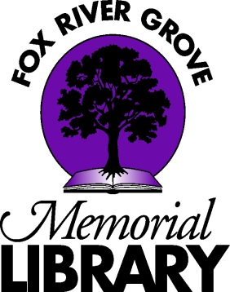

Fox River Grove Memorial Library
Job Description

ASSISTANT TO THE DIRECTOR

The Assistant to the Director assists with the smooth operation of Library administration and also serves the public with circulation and reference services. This is a part-time, 16-hour-per-week, non-exempt position. The Assistant to the Director reports to the Library Director.

ESSENTIAL JOB FUNCTIONS
- Assists the Director in a variety of administrative tasks using Microsoft Office 365
- Updates Library intranet contents under Director’s supervision
- Prepares statistics and reports for management review
- Mails out monthly bills, files invoices, makes copies for monthly board packet
- Assembles documents for annual audit under Director’s supervision
- Keeps Library files updated according to Records Retention rules under Director’s supervision
- Checks administrative email accounts
- Coordinates with Adult Services Librarian and Youth Services Manager to schedule desk and page shifts
- Posts board and committee agendas in the library and emails agendas to news agencies
- Tracks meeting room reservations
- Fulfills all opening and closing procedures
- Works circulation desk and all related duties, including troubleshooting minor computer and printer problems for patrons, shelving materials in the absence of pages, and ordering interlibrary loans
- Answers directional, general reference, and readers’ advisory questions
- Assists patrons in the use of library-provided mobile apps
- Balances fines, fax, copier, and book sale money weekly for banking and prepares deposit paperwork
- Attends and participates in all staff meetings
- Attends educational workshops when possible
- Assists Adult Services Librarian with Collection Development as assigned
- Backs up Library Director to fulfill FOIA Requests
- Other duties as assigned

ESSENTIAL QUALIFICATIONS
- Education: Some college or university courses.
- Experience: 1-3 years’ work experience
- Skills: Microsoft Office, email, and familiarity with web-based searching and applications are required. Able to coordinate complex filing. Able to pass background checks including credit check. Basic understanding of accounting. Comfort with working with the public. Demonstrates an understanding of the importance of teamwork in a small library. Able to multitask. Able to prioritize tasks appropriately. Comfort with 21st-century office technology.

PHYSICAL DEMANDS
The physical demands described here are representative of those that must be met by an employee to successfully perform the essential functions of this job. Reasonable accommodations may be made to enable individuals with disabilities to perform the essential functions.

While performing the duties of this job, the employee is regularly required to stand; walk; use hands to finger, handle, or feel; and reach with hands and arms. The employee is regularly required to talk and hear. The employee must regularly retrieve from and replace books and files on high and low shelves. The employee must occasionally lift up to 25 pounds and/or push carts up to 50 pounds. Specific vision abilities required by this job include close vision, distance vision, depth perception, and ability to adjust focus. Typing on a computer keyboard and interacting with computer screens are required.

