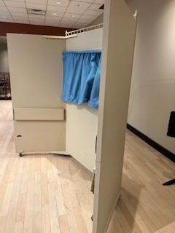
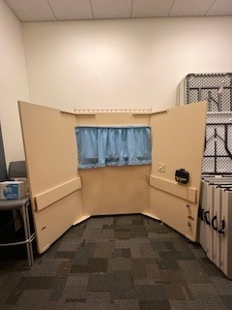
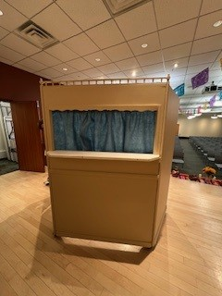
Height: 74”
Front of stage: 51” across
Back of stage:: 83” across
Each side panel: 32” deep
Has an electric outlet but unknown if it works. One side shelf on the back of the stage folds down and the other does not.

