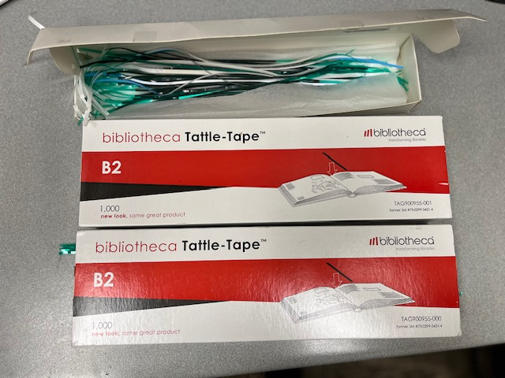

**Security strips 2.5 boxes**

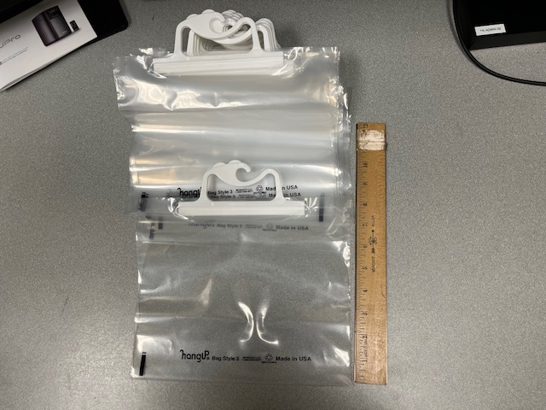

**12 bags style #3 “hangups”**

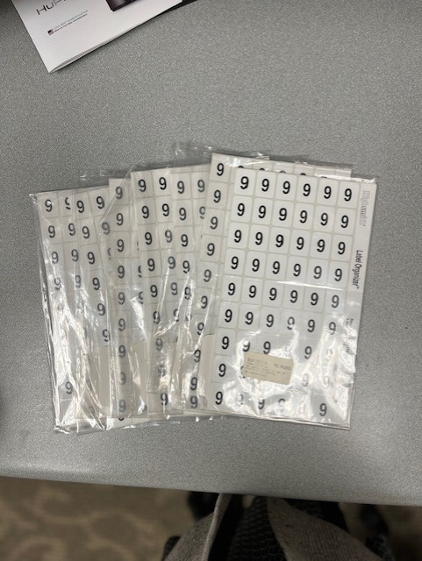**7packages of number 6 or 9**

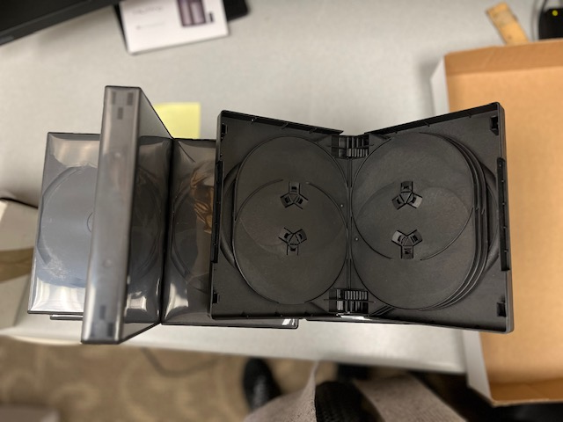**10 DVD/CD cases (10 discs)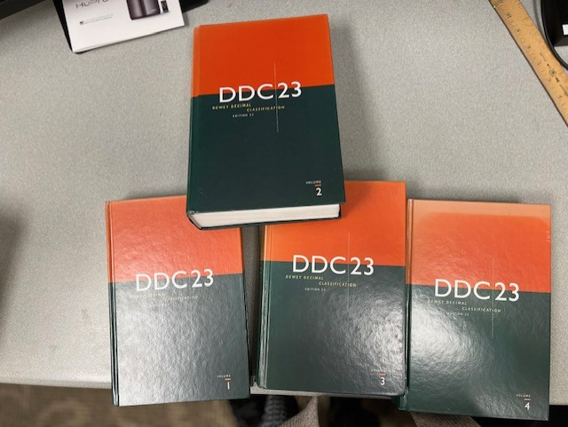DDC 23 vol. 1-4**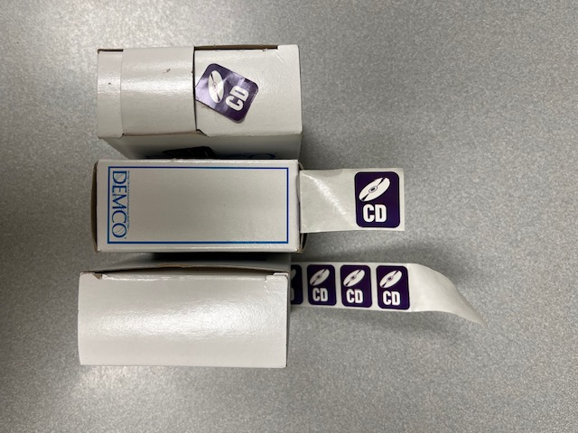

**3 boxed purple CD stickers**

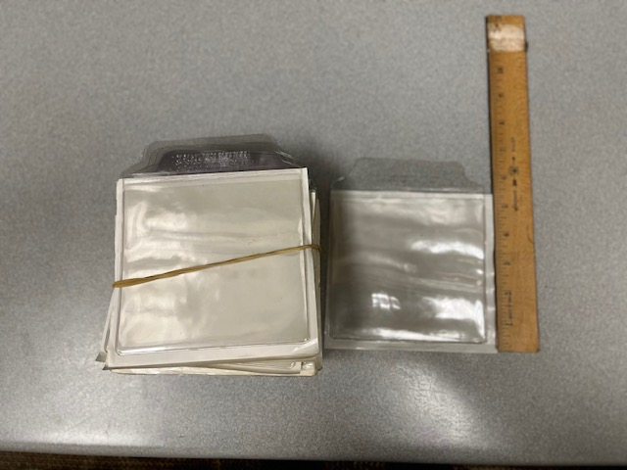

**Single CD adhesive envelopes (approx. 30)**

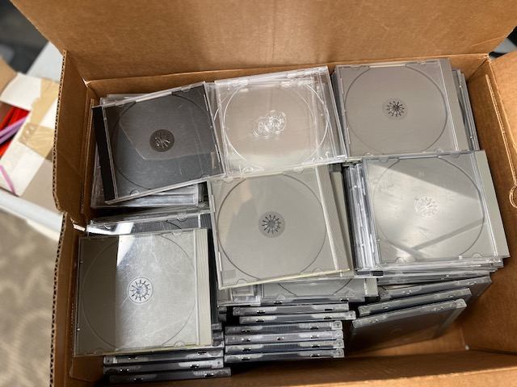

**Single CD jewel cases ( 2 B&T boxes full)**

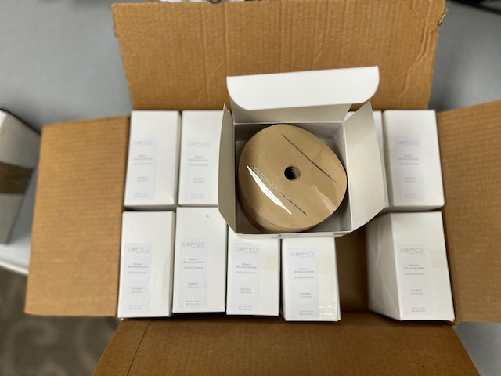

**CD security overlays-Demco 12 full boxes**

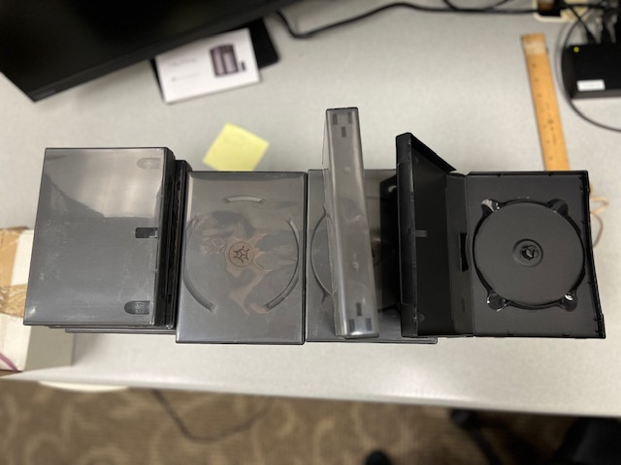

**6 disc DVD/CD 21cases**

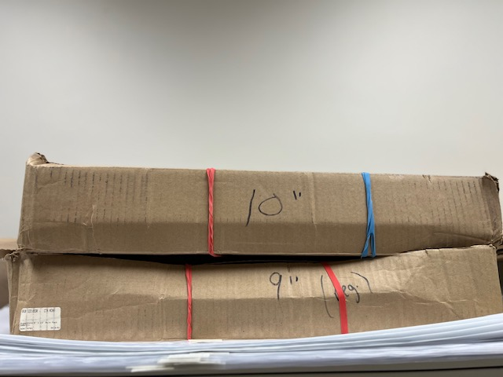

**9”, 10, 12” Mylar covers**

**Multiple lenghts**

