The below items are all currently available.

1. 4 drawer filing cabinet **$30 or will trade for 2 drawer filing cabinet.**
2. UNINET iColor Paper – Universal 2 step textile transfer paper **$50**
3. Xbox 360 Kinect **$10**
4. DragonPad Pop Filter. **Make an offer**
5. Lights for photography. **Make an offer**
6. Giant spool of lace trim. **Make an offer**
7. Handycam Video 8 camcorder. **Make an offer**
8. VHS to DVD converter with monitor. **Make an offer**
9. Large box of stamps. **Make an offer**
10. Tea light making kit. **Make an offer**
11. DVD cases. **Make an offer**

A. B. C. 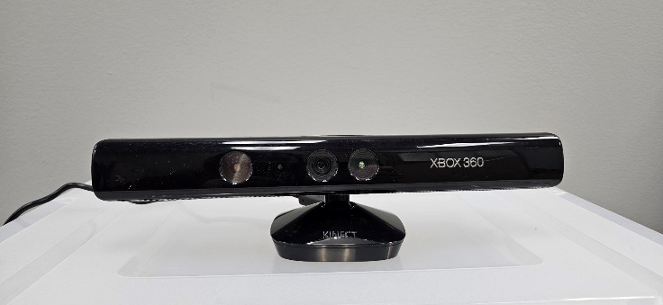 D. 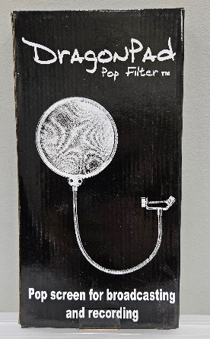 E. 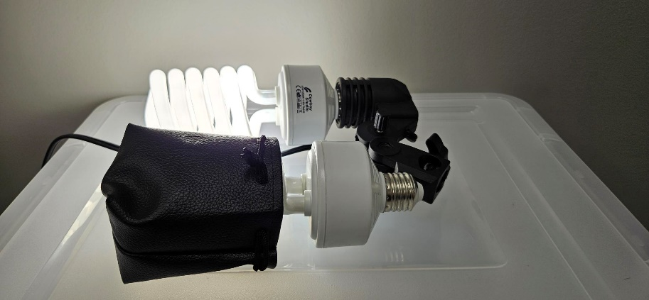

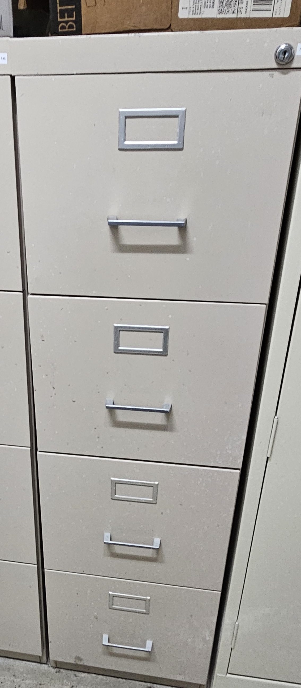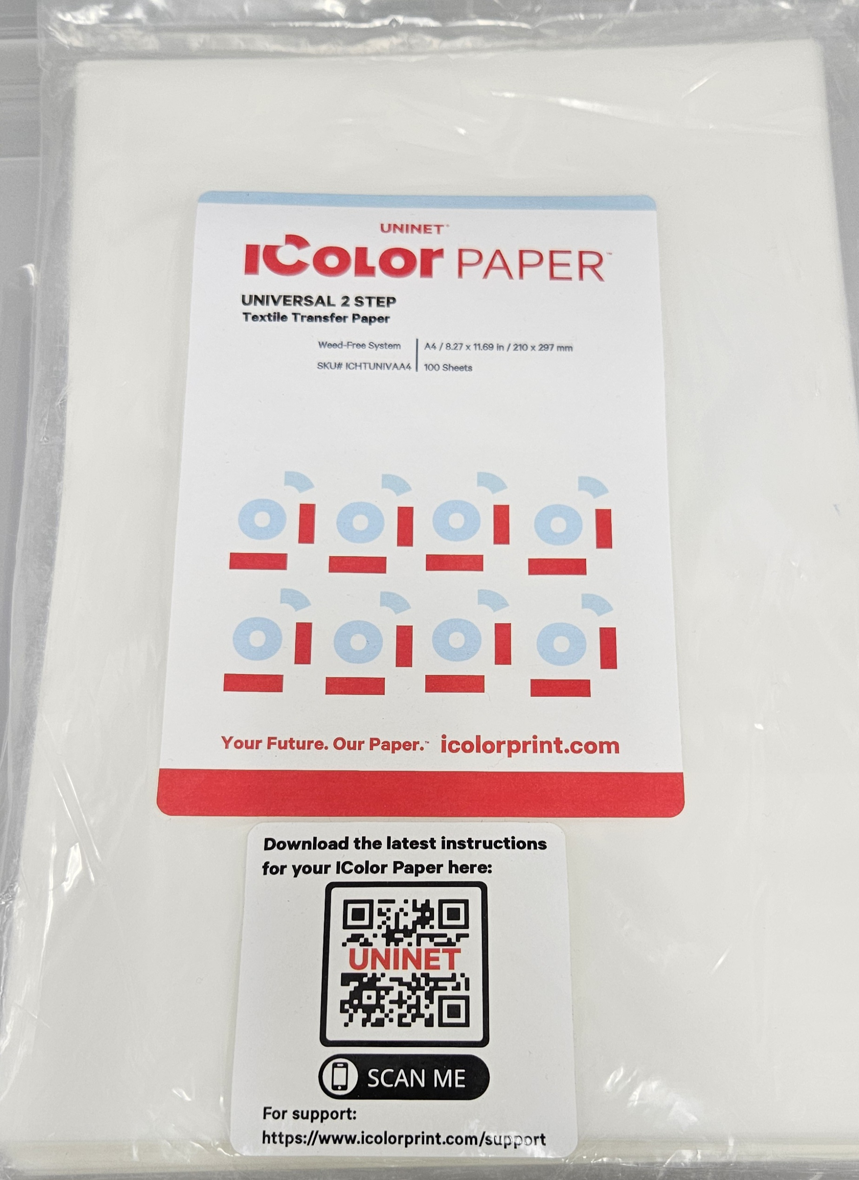

F. 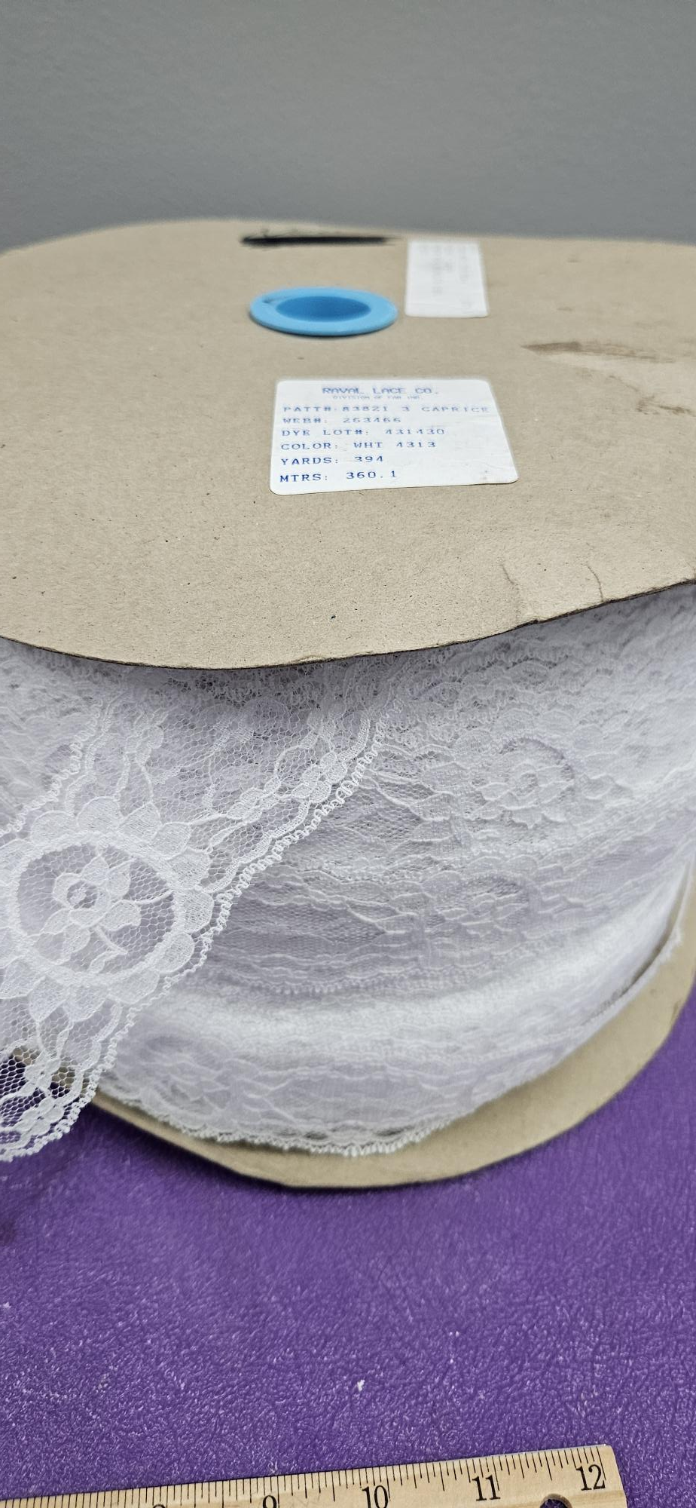 G. 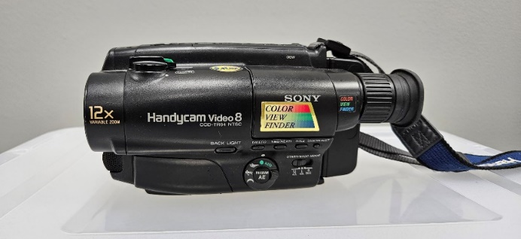

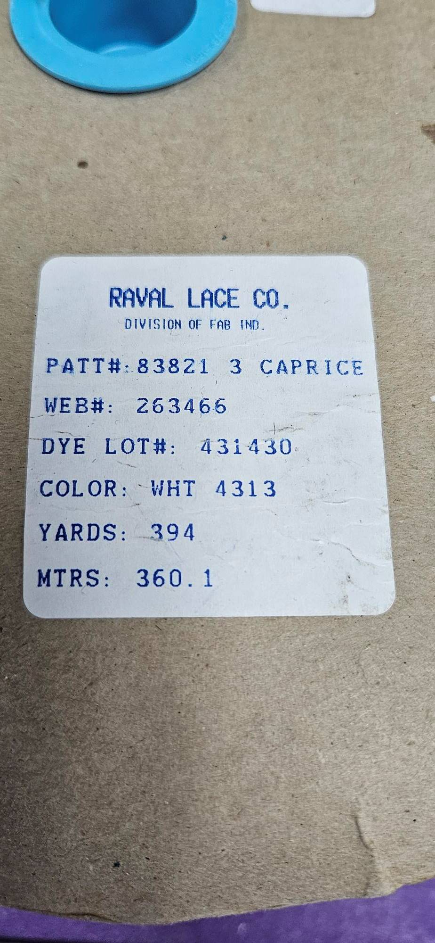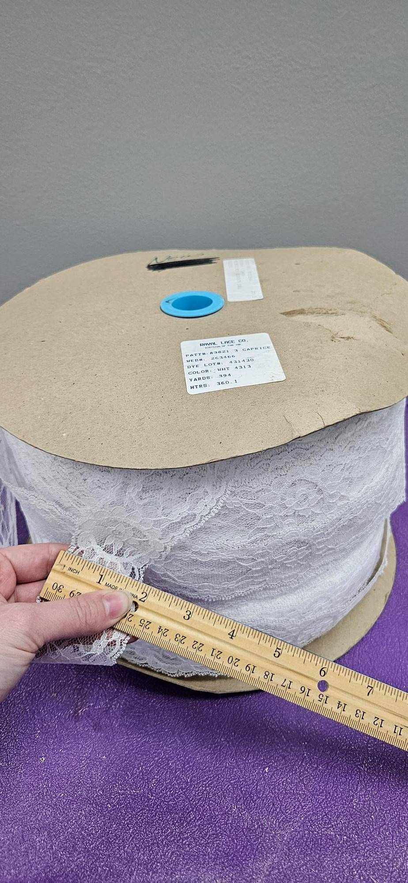

H. 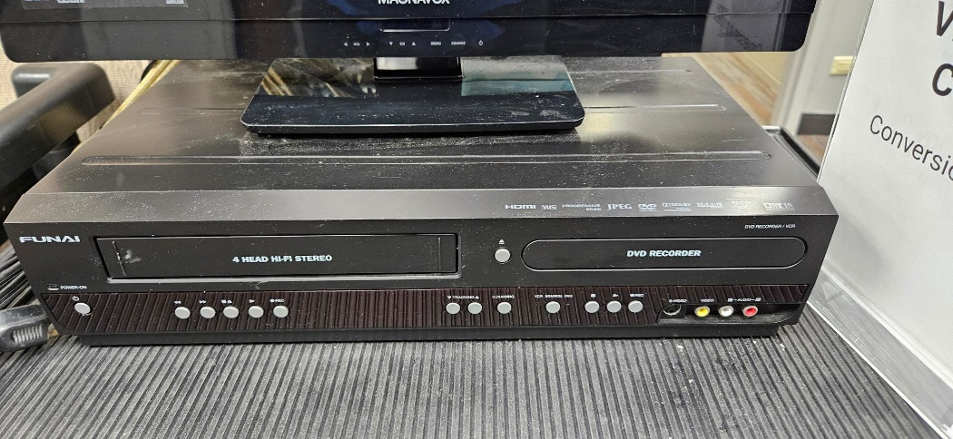

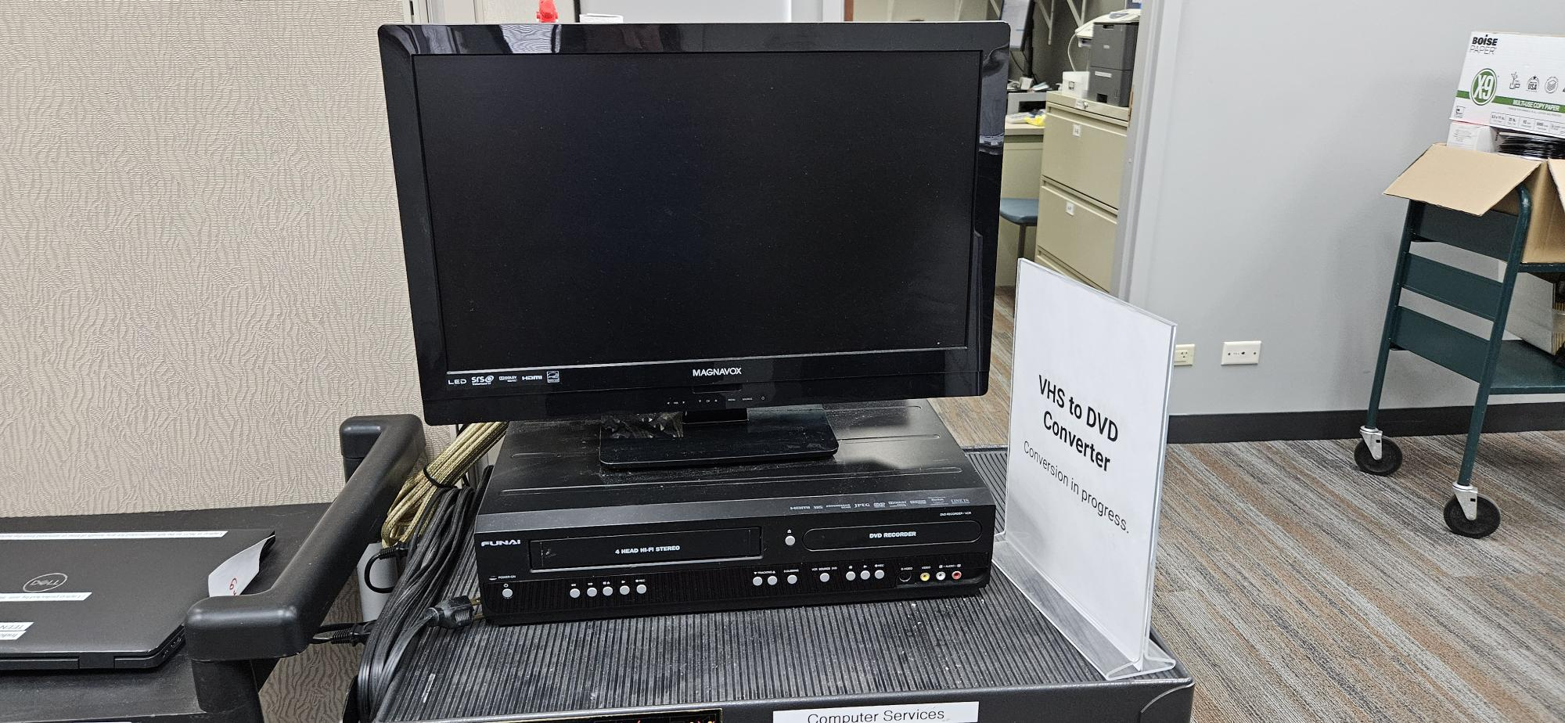

I. J.

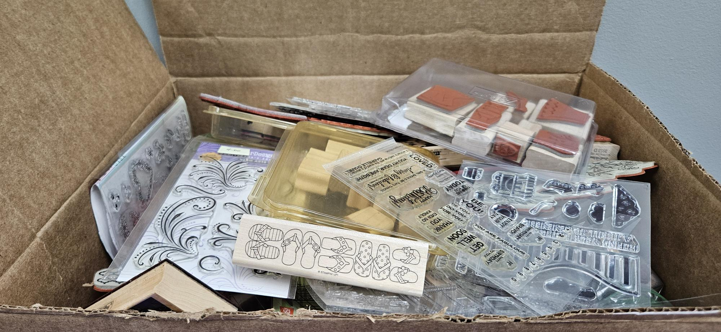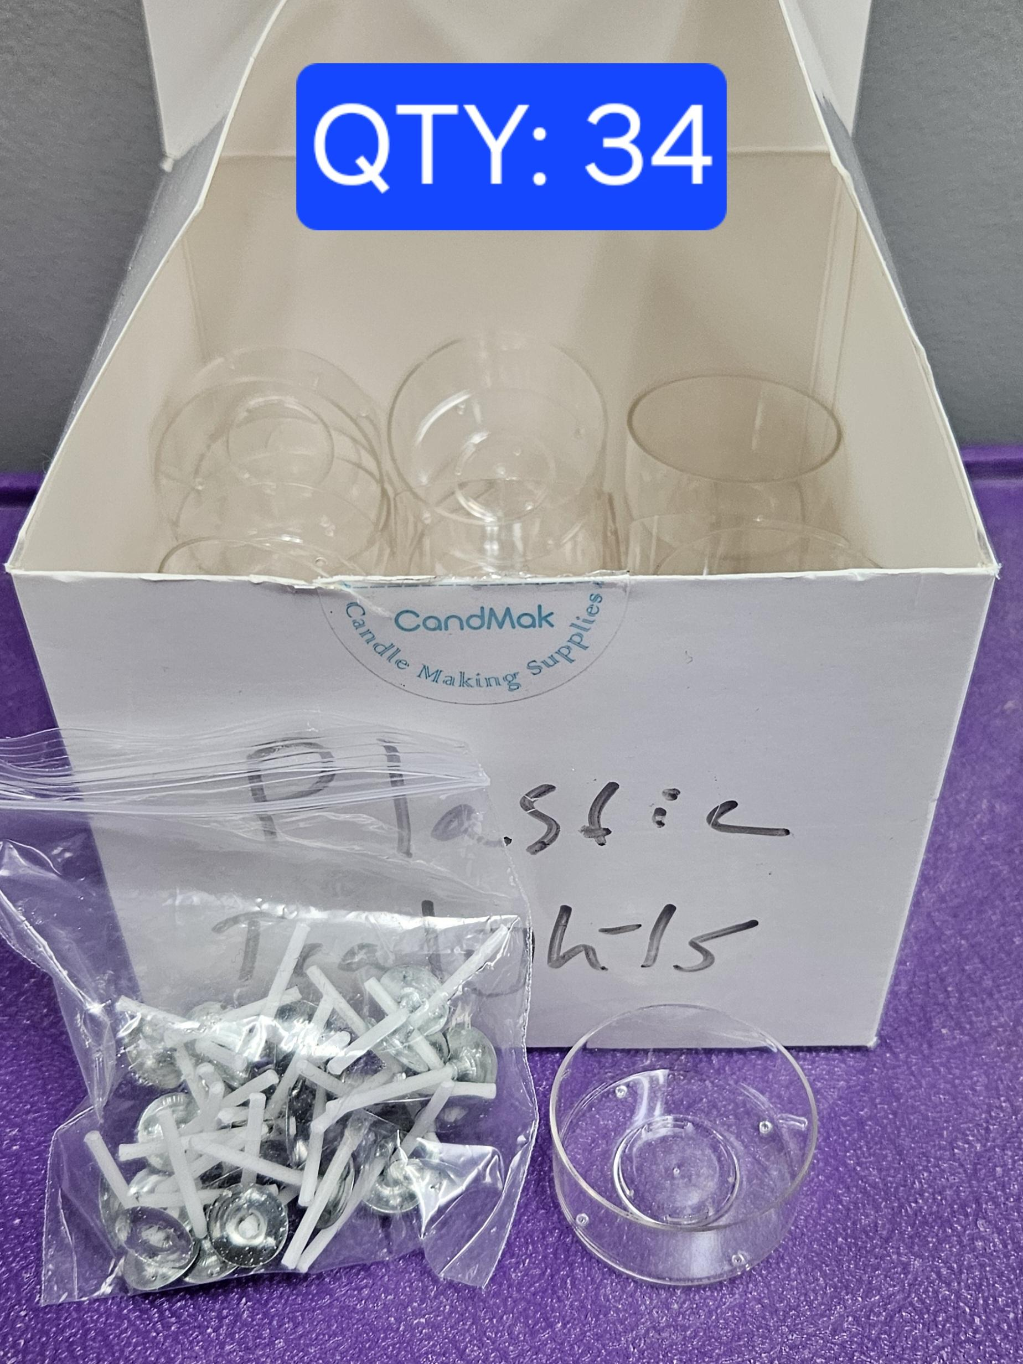

K. 